JAVASCRIPT FUNDAMENTALS
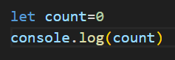
Console can be said similar to a serial monitor in Arduino where we basically see how the value gets printed in the monitor or what output is being delivered by the current functions.
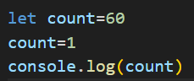
Above shows reassigning of values
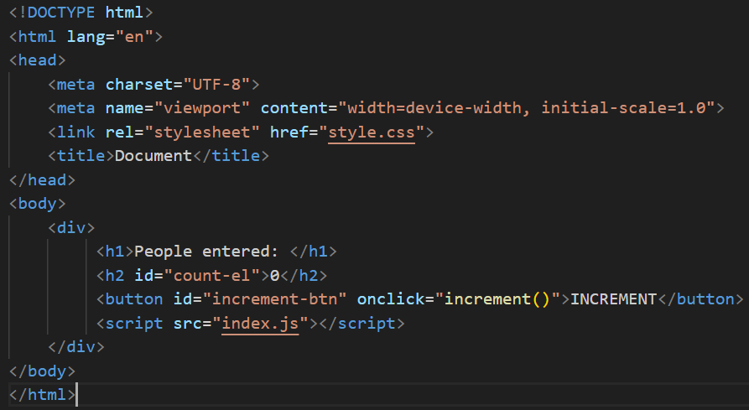
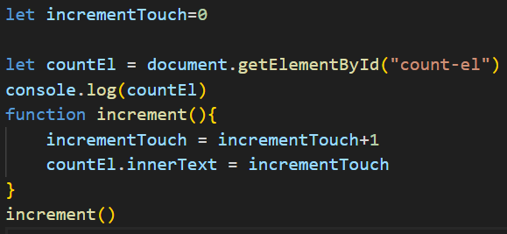
You can use Mozilla developer networks (MDN)

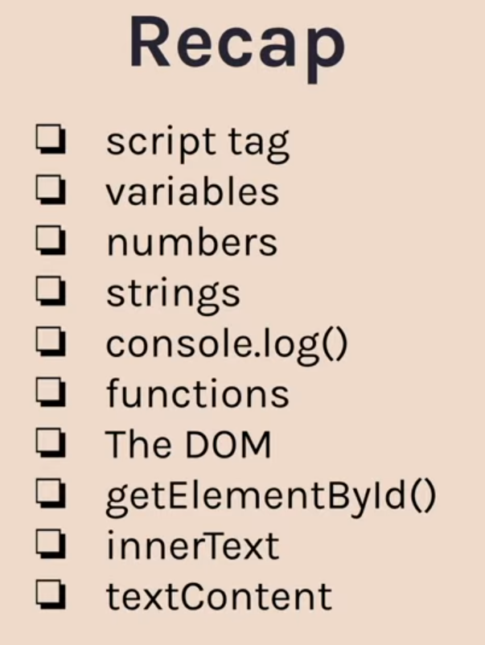

The middle example is very important as we can see that since one string is present so everything inside log will be treated as string.
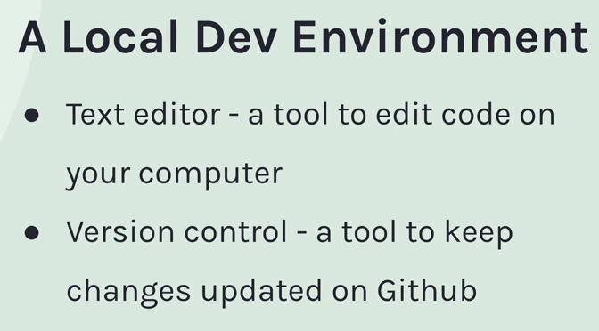
The tool which we are going to use for version control is GitHub desktop.
A repository contains all the files and folders which your project requires.

You will have a repo which lives on your computer and a repo which lives on the internet. GitHub desktop helps in syncing both repos.
Before uploading in Github online, we first need to commit it in Github desktop that is we keep record of the changes we make.
Record of these changes – “COMMIT”
Publish the commits which are being made – “PUSH”

IF-ELSE CONDITIONALS
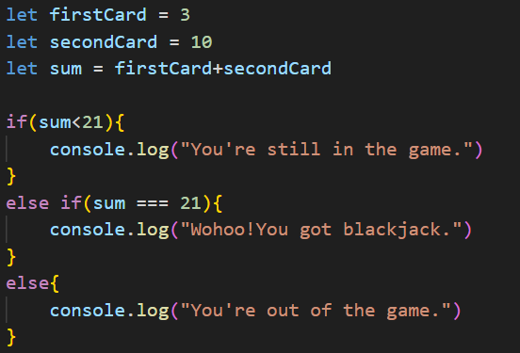
Difference between double equals ( “==” ) and triple equals ( “===”)
Triple equal is strict with the fact that it’s comparison is being done with that of a integer or a numerical value whereas double equal compares despite of whether it is integer or string.
In Java script the string “” means false
So if we write if (“”) { } then the code written in this if statement will never run as it is false.
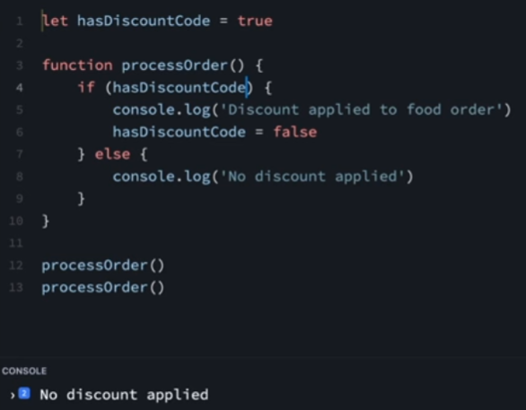
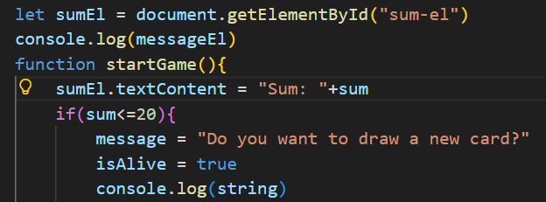
Another way of accessing elements from the html document in javascript is through the
“Query Selector”, but we have to specify in the “” whether the element is an ID or class.
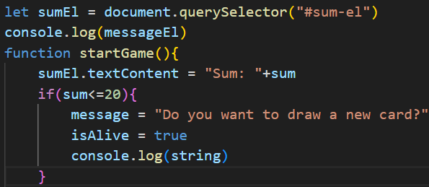
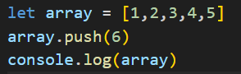
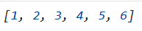
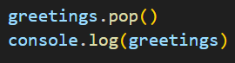

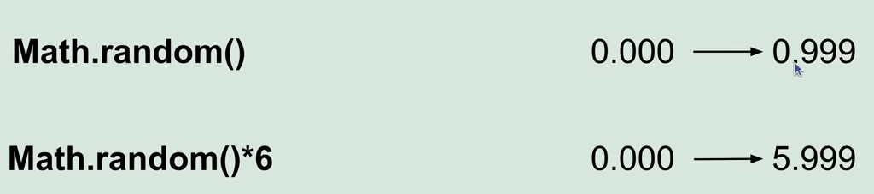
VVIP to use Math.floor( ) as in most of the cases we won’t be requiring the decimals part.

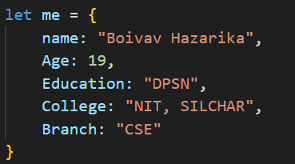
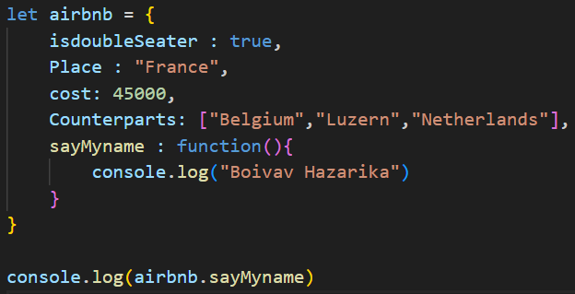
The thing shown above is an example of a function inside an object.
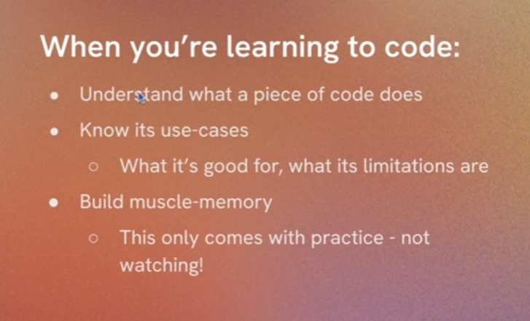

If you use AI to generate code, make sure the following things:
- Understand the code.
- Verify it from a non-AI source.
- Write it yourself without looking.
- Ask why ?
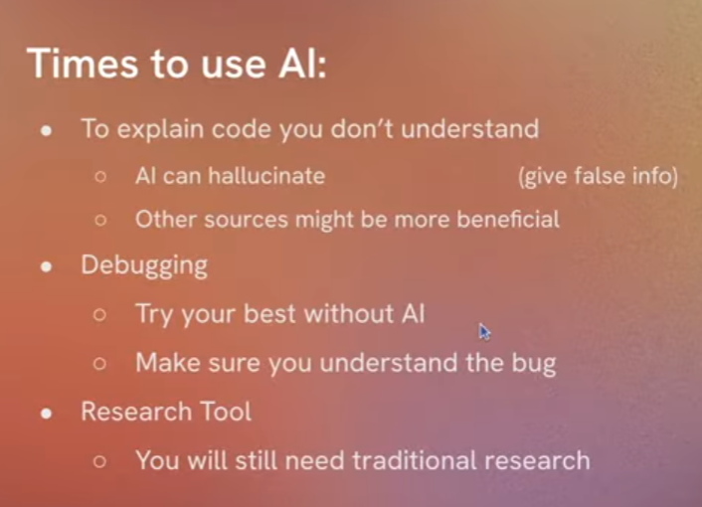

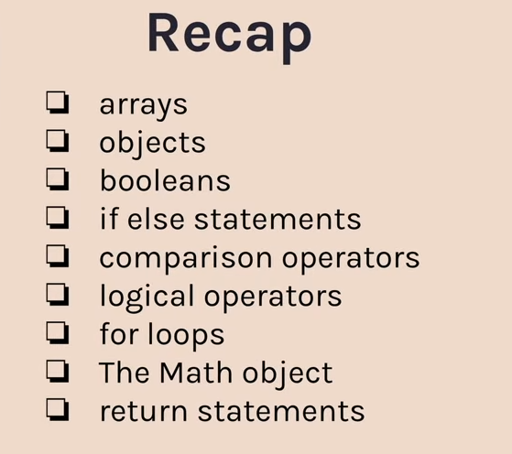

Some functions in Javascript
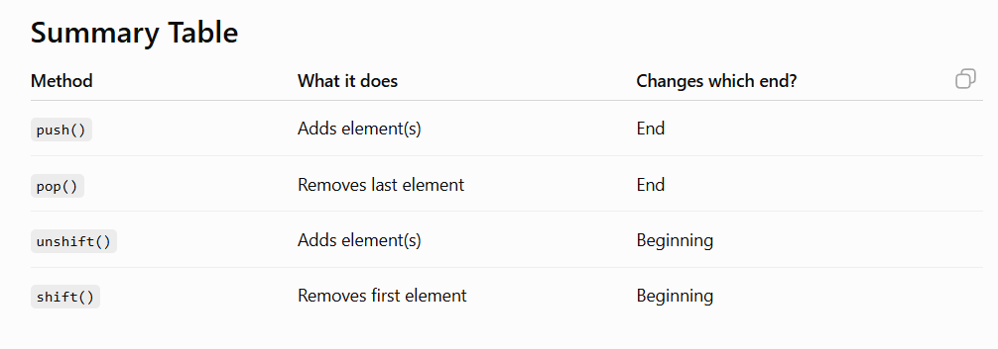

Refactoring to .addeventListener

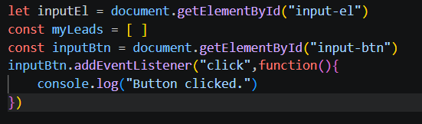
In modern Javascript, we use let and const for assigning variables.

The difference between them is that when we use const the variables can not be reassigned.

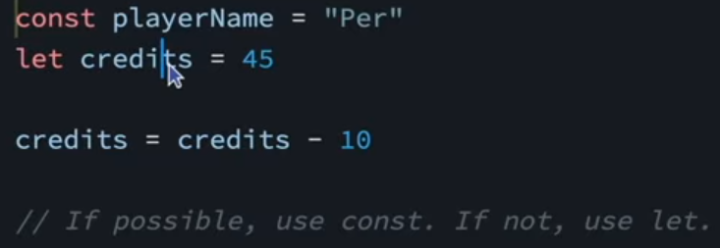

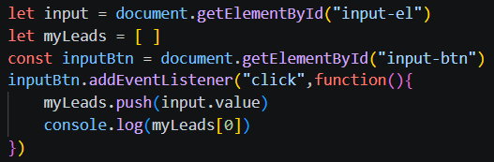

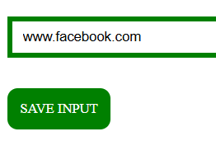
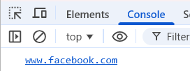

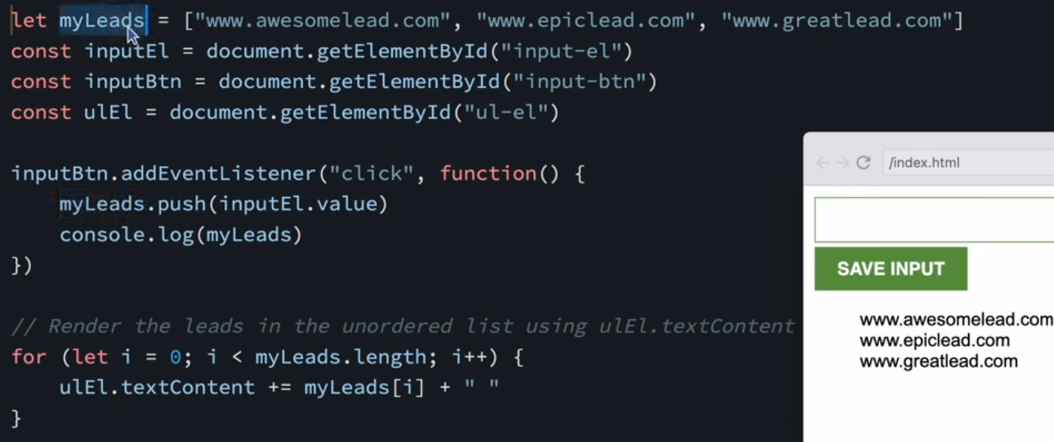

MANIPULATING THE HTML file in JAVASCRIPT using INNER HTML

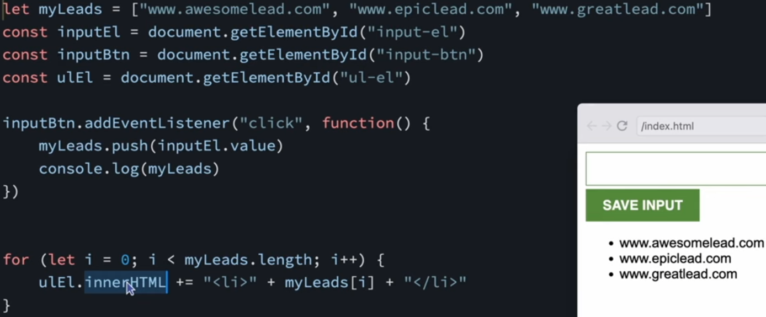

Using inner html to add something to the html file which was initially forgotten while creating the file.


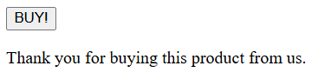

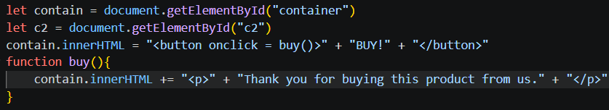

Make sure to use the += symbol so that we can add every single element in the html file we want to otherwise only a single element will be added.

Appending means to add something at the end of the document.

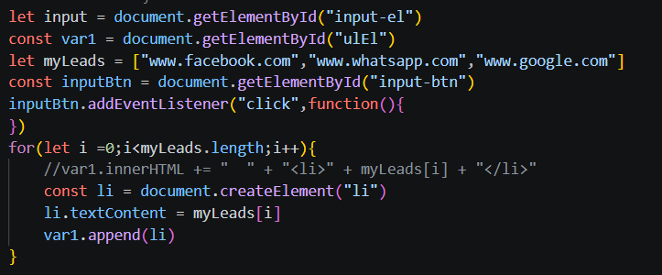
Another way of using InnerHtml.

Instead of using innerhtml again and again while iterating through the loop, we use it only once after adding all the html to a single variable.

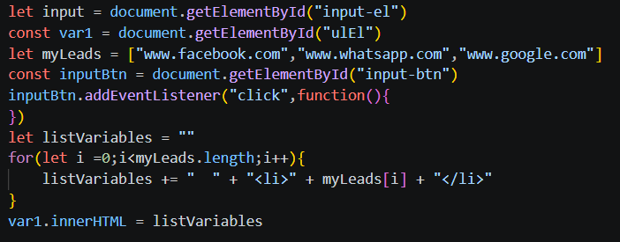

By simply putting input. value , after we have pressed the input button whatever we typed will again go blank and a fresh new tab will appear.

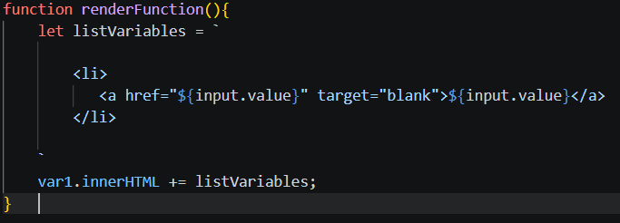

Make sure to use backticks in this case instead of using single exclamation marks.
When we use the back ticks ( `) then the string which we get is known as Template strings.
In template strings there is no need of using plus symbol.

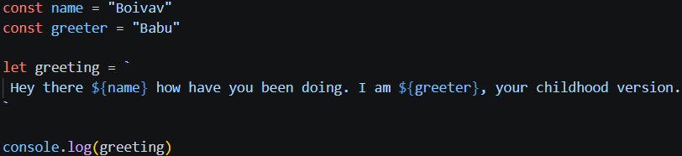

Use the ${ } symbol to insert any previously defined values.

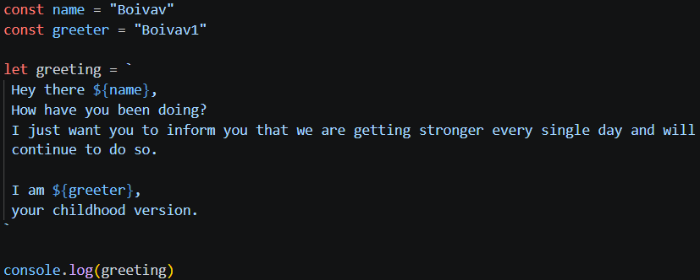

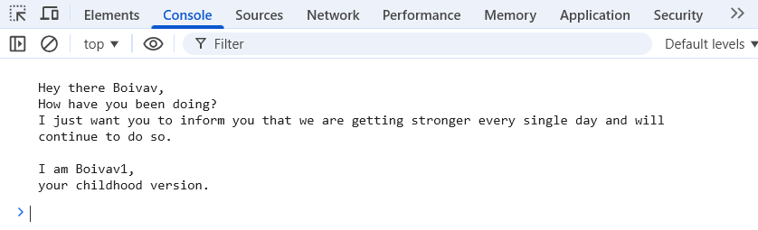

By default whatever values we type in the input box we will be in string only.
We need to use the Number( ) function in order to convert it from string to number.

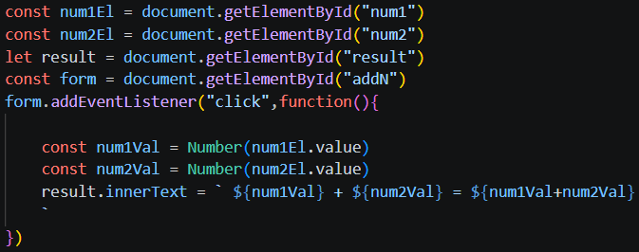

JSON – JavaScript Object Notation
It is a medium through which we store and send data.

How to upload an extension to Chrome?
Go to extensions and turn on developer mode, then go to load unpacked and then accordingly press the folder which contains all the required files for the extension to function.

When we refresh the chrome tab then everything that has been stored in the extension disappears. We don’t want that to happen. Therefore this is where the concept of Local Storage comes in.

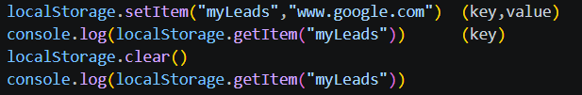

Local storage only supports strings.

myLeads.push( input.value) – The push function exists only for arrays not for strings.

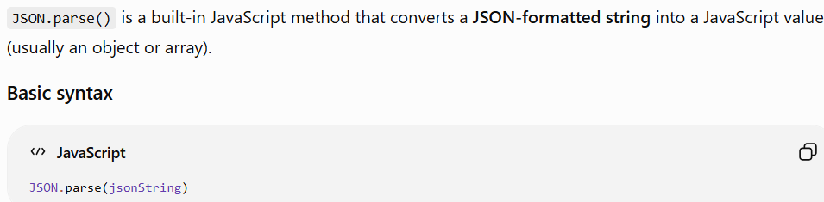

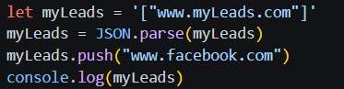
First we define array string, then we actually convert the array string into an array using JSON.parse and then since now it is array we can use the push function to add a website value to it and then we print out that value in console.log( ).

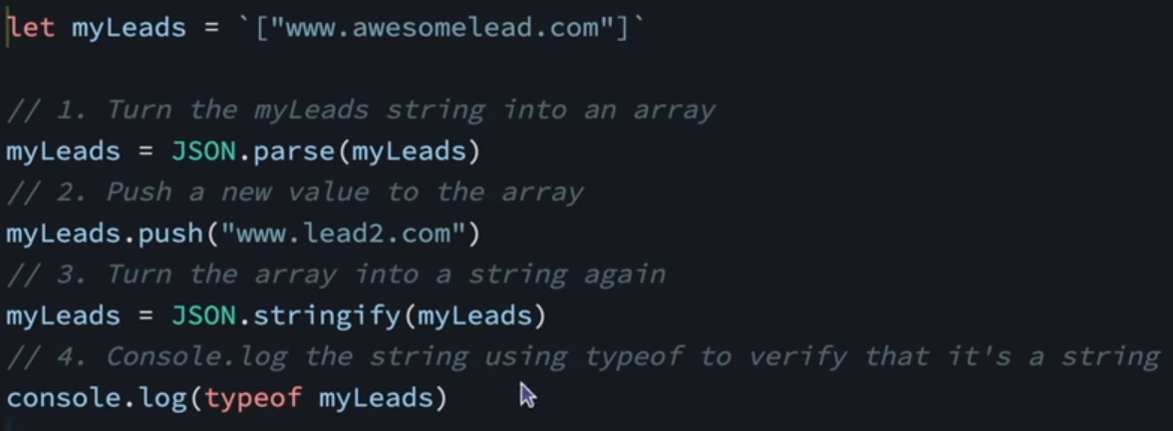

.parse – convert string to array
.stringify – convert array to string

Falsy values

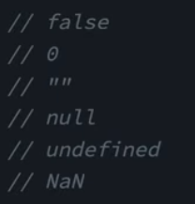

It is very important to know the difference between falsy and truthy values.

The values give above are falsy values.
NaN – Not a Number

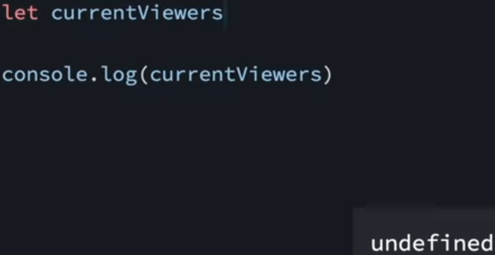

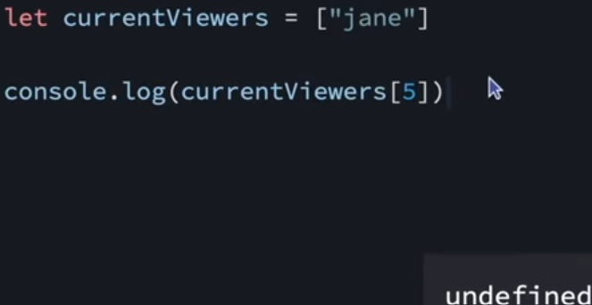

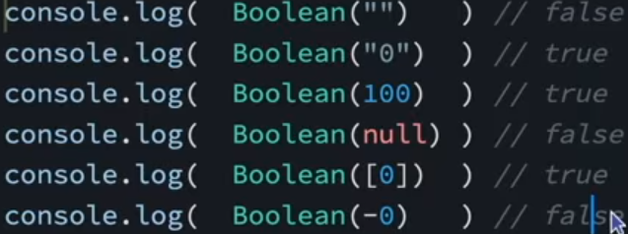

We use the Boolean( ) function to basically see whether the given value is truthy or falsy.

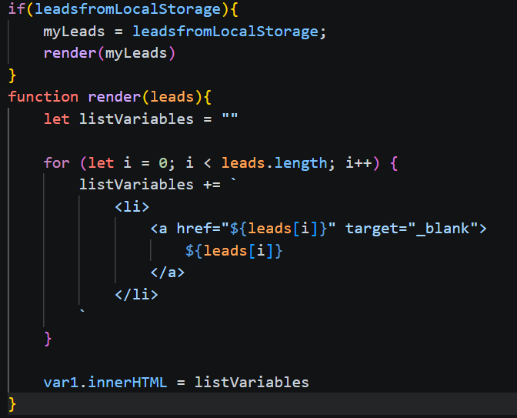
We basically use parameters to improve the reusability of a function and to make the function more dynamic such that we can insert any type of value in it.

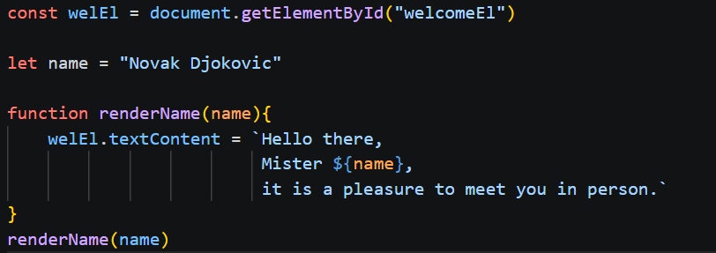

Arguments are created outside of the function whereas parameters are created inside the function itself.

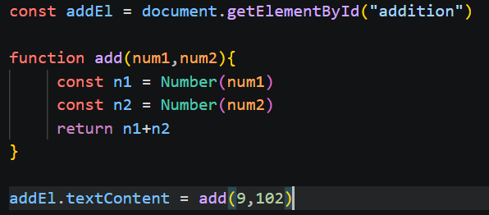
Here in this document we see that 9,102 are the arguments and num1 and num2 are the parameters.

An easy trick is to remember the diagram given above.

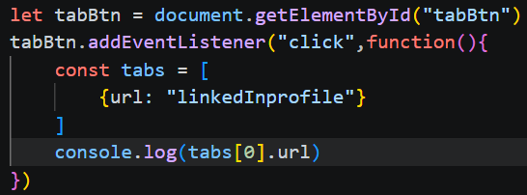

Above code shows how we are basically logging out the link in the console through the array while excluding the key .

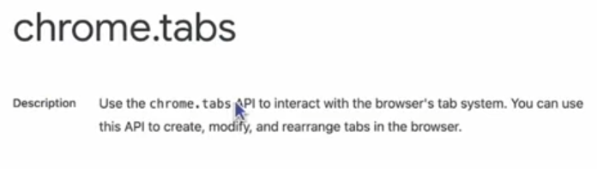

The code for using the chrome API in order to get the link of the current tab the browser is open on.

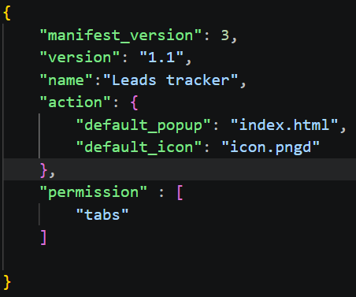
We have made the permissions part so that chrome allows us to access the tabs which we are currently using.
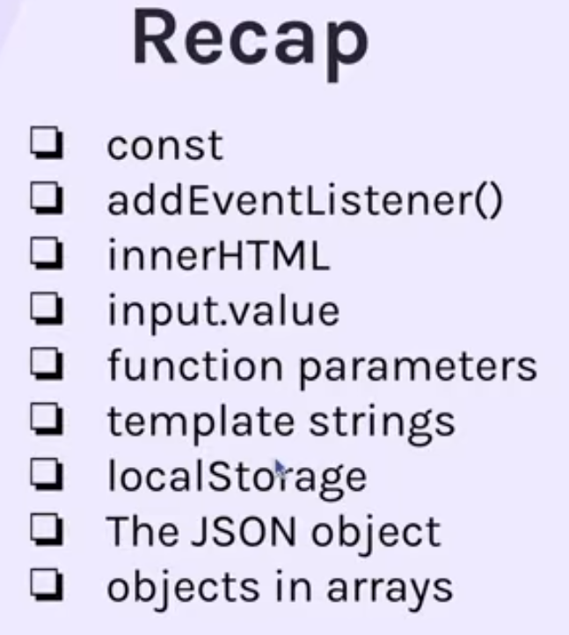

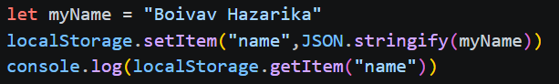

Even after deleting the first two lines it still logs out the same value which is Boivav Hazarika.
That is because the value got stored in the local storage.
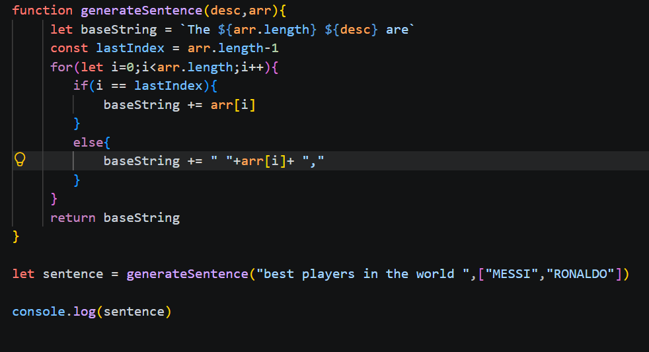

The solution to convert ten decimal places to two is by using the function toFixed(number of decimal places) but we need to make sure that the input value is a number.
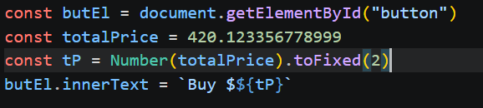

TERNARY OPERATORS

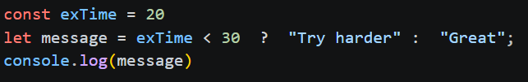

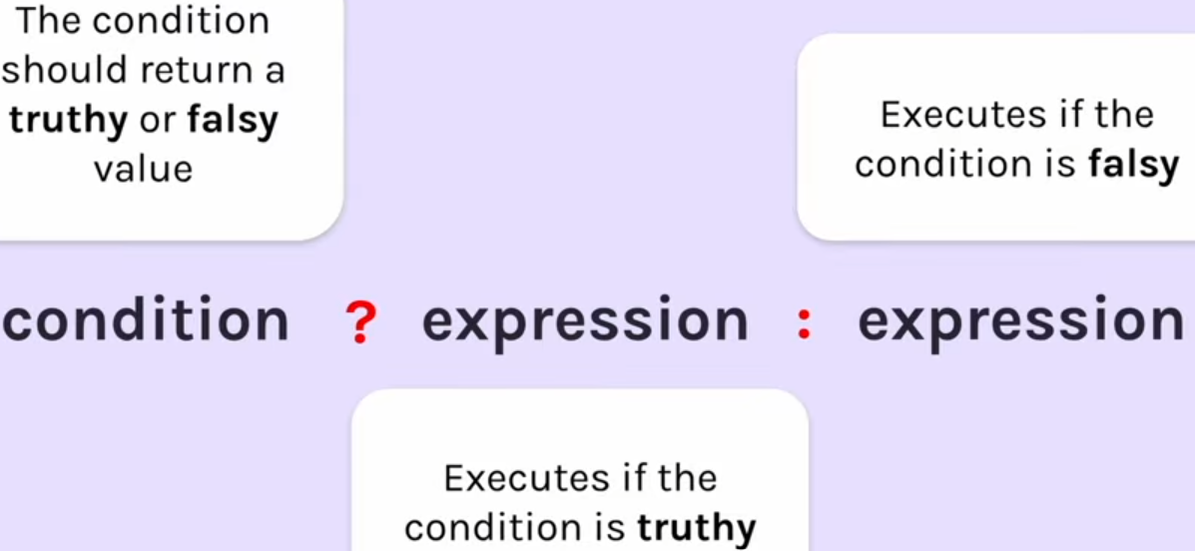
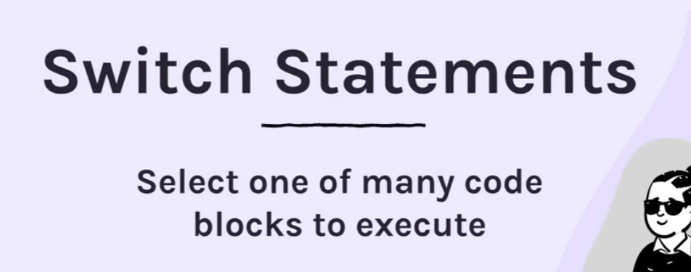

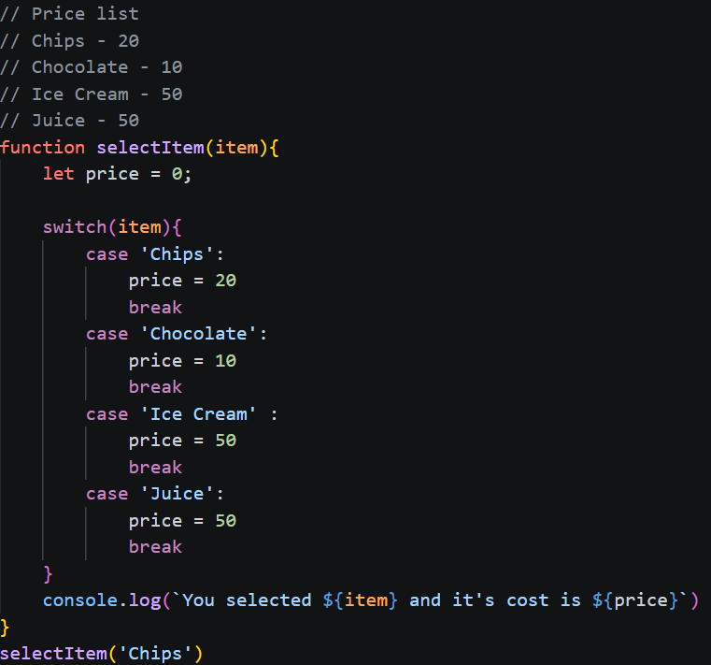

It is very necessary to use ‘break’ while using switch statements.

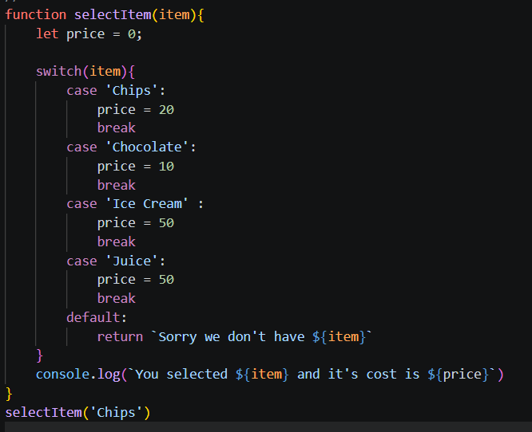

Make sure to include default while using switch statement.


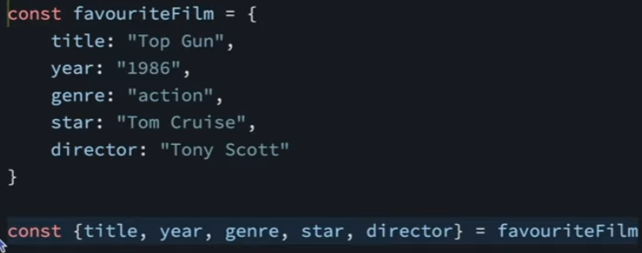

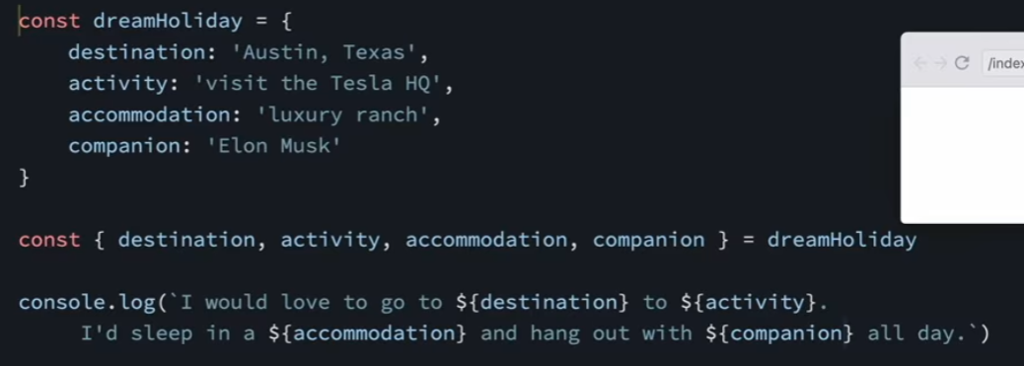

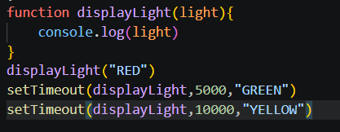

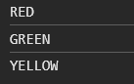
First RED appears, then after five seconds Green appears and then after five seconds Yellow appears.
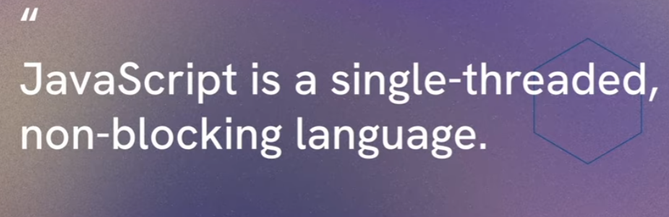
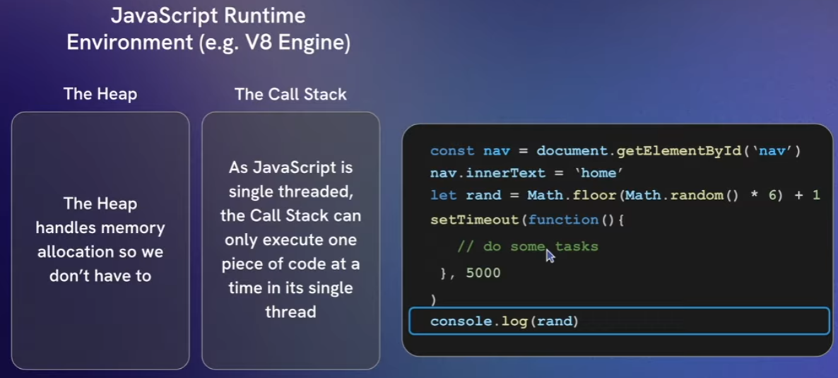

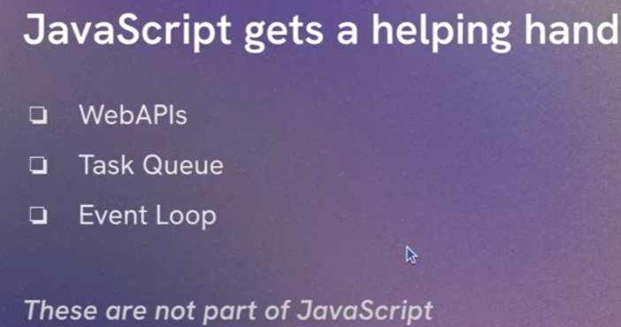
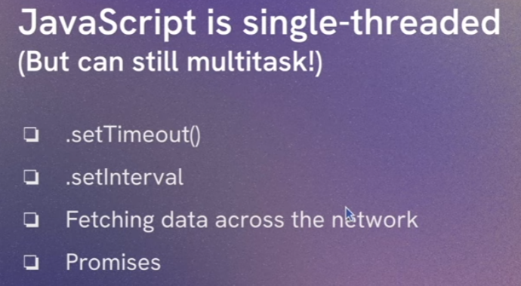
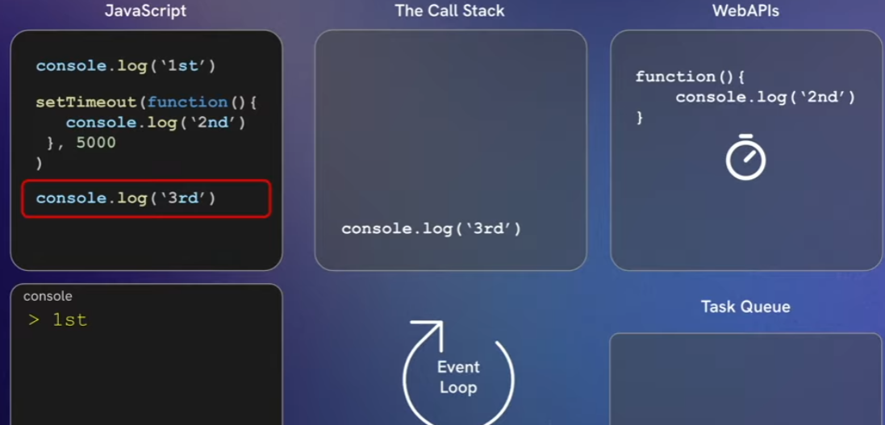
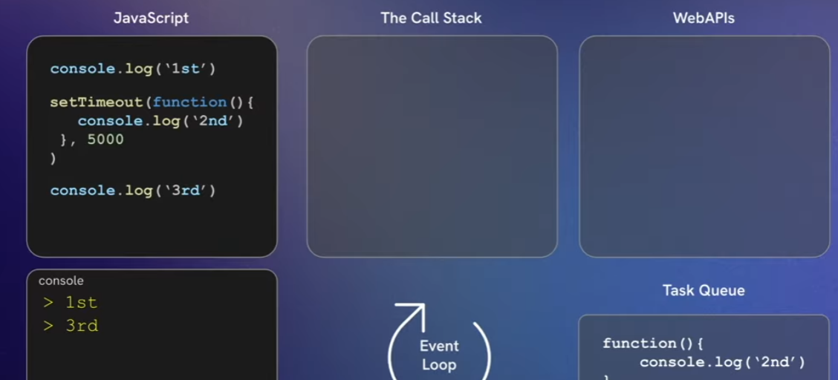
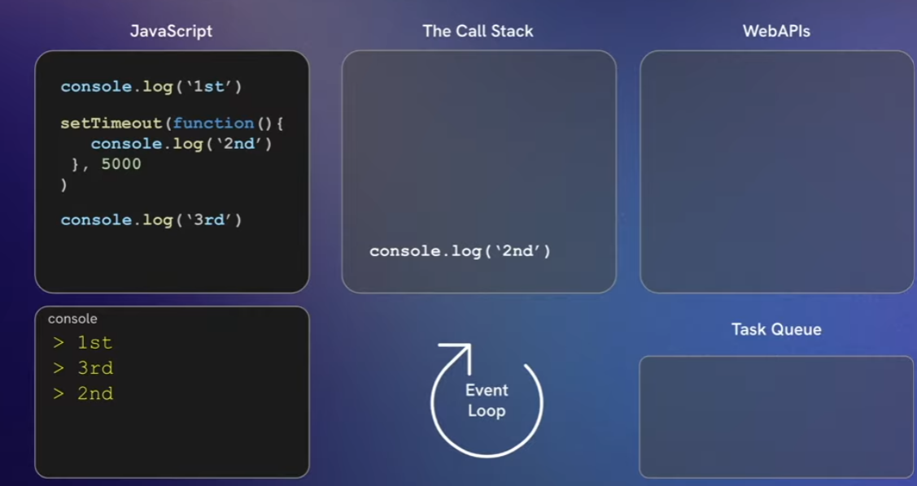

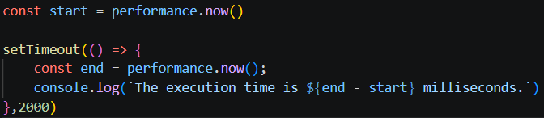
We can see that there’s a time lag. This is because the function setTimeout mainly does the job of making sure that whatever is present inside it must not happen before 2000ms , the actual output is not 2000 because the Call stack consists of some other tasks, and Javascript can execute only one single task at a time.
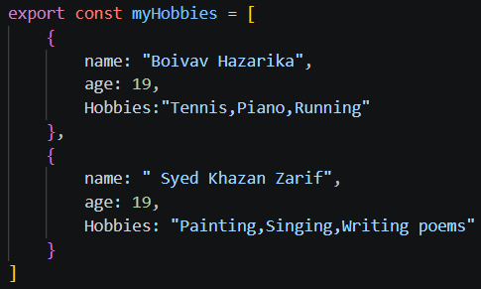
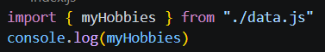
Also make sure that for import and export to work in index.html we must write
Under script tag type = “module”
The difference between export and export default is that in the case of export default we can call the function or object or array by any name as and when we are importing it to different javascript file.
We can only have one export default in the whole javascript file.

Constructors give us objects.
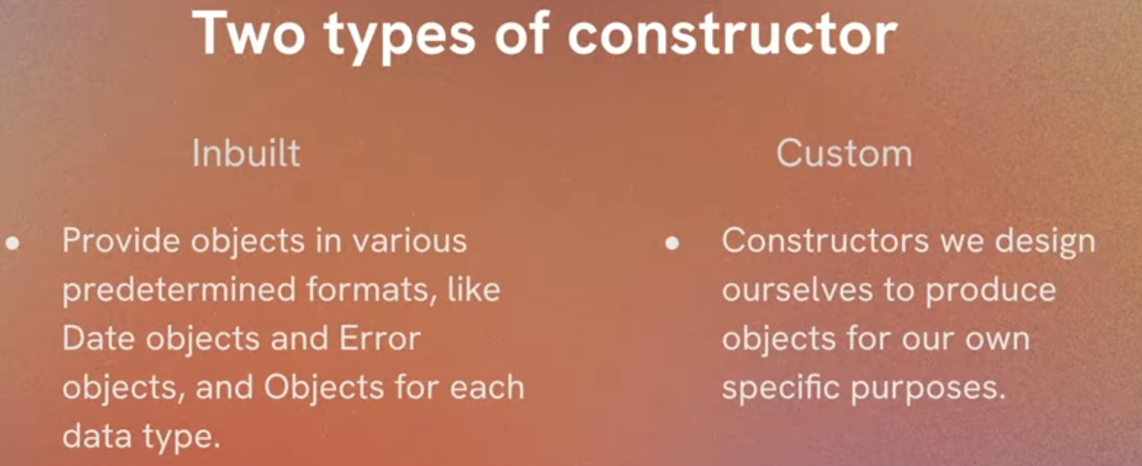
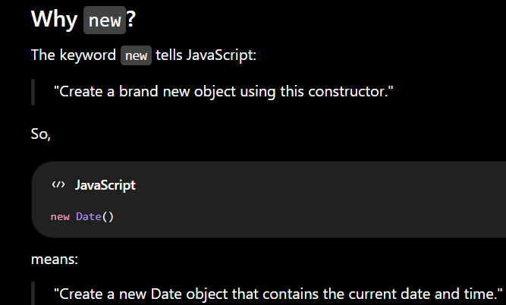
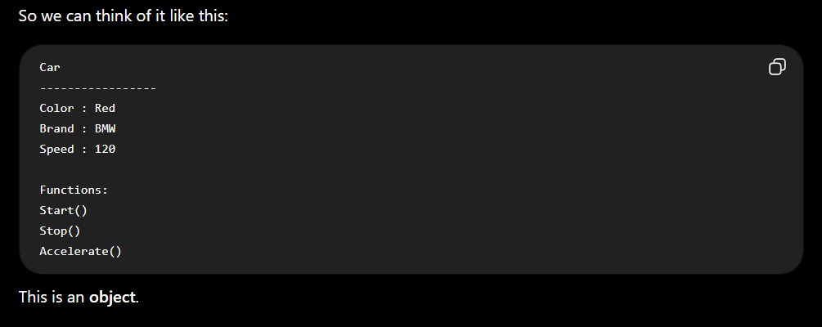
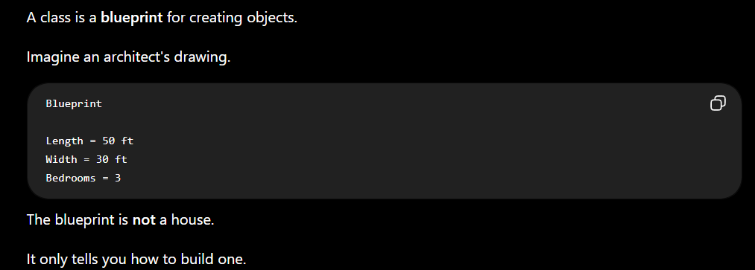
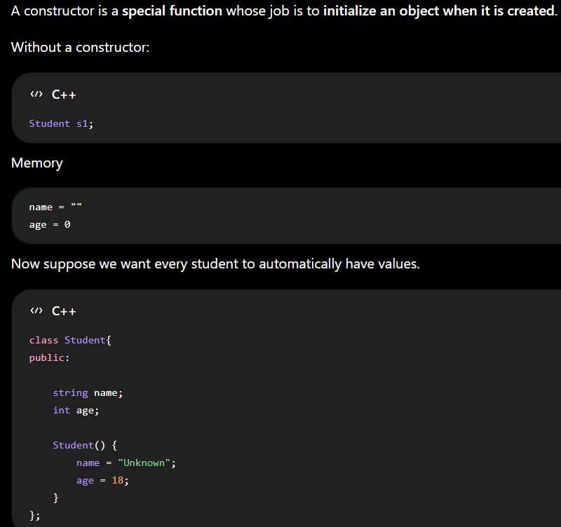
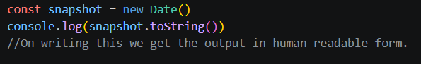
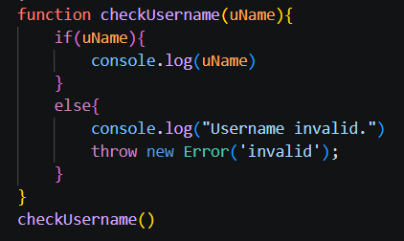
If we write the throw keyword it will come with cross mark but every piece of code written after it will not get executed.
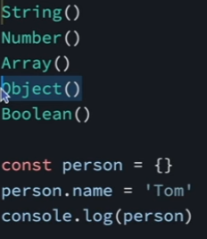
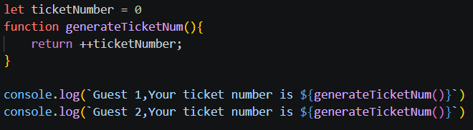
In the above example we see the functioning of pre-increment operators.

Big Int is used for very large integers.
\
This is known as the “HOISTING” property in JavaScript.
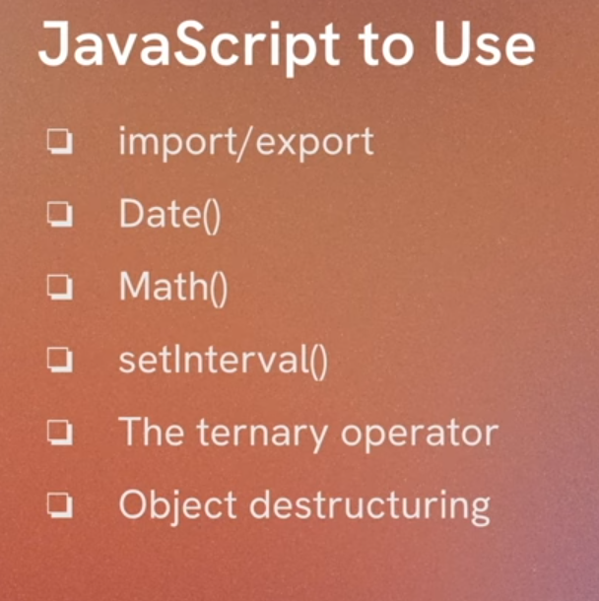
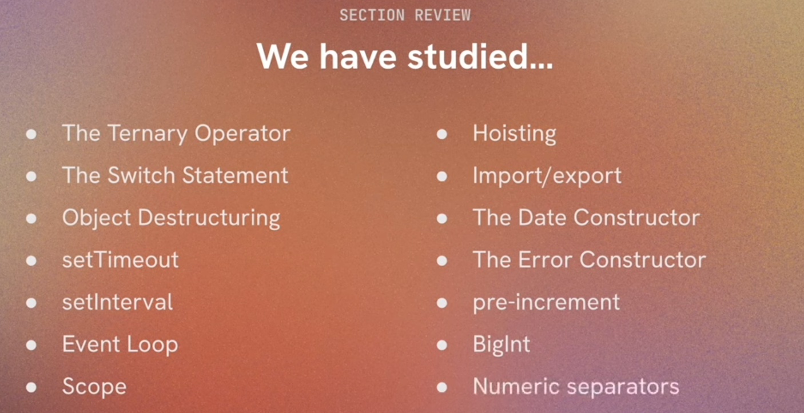

ARROW FUNCTIONS (ULTRA CONCISE FUNCTIONS)
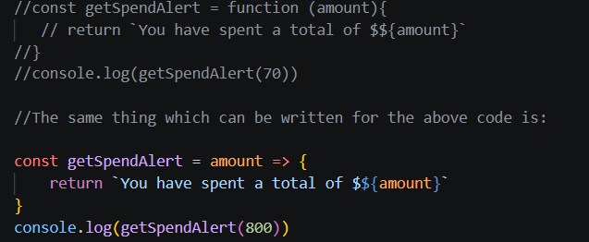
When we have a single parameter, we can remove the brackets and accordingly execute the piece of code.
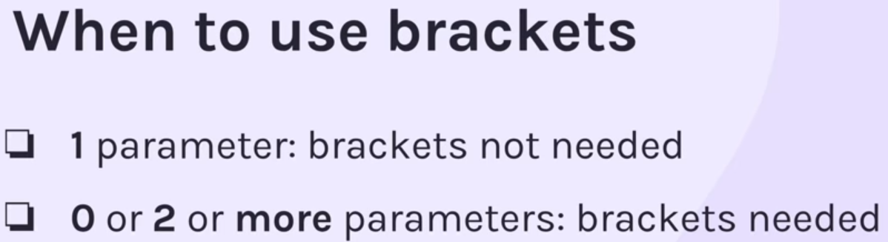
Most precise one line function arrow function obtained after removing return and curly brackets.
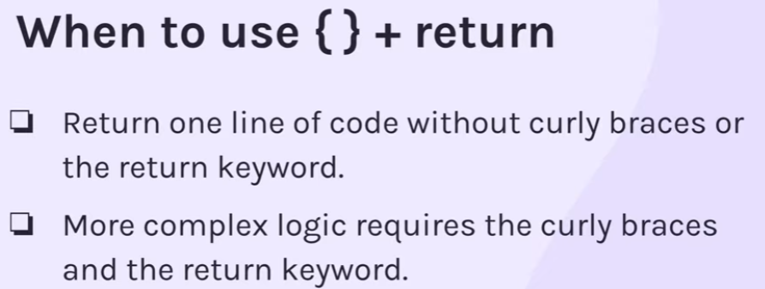

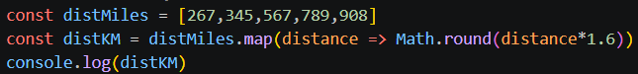
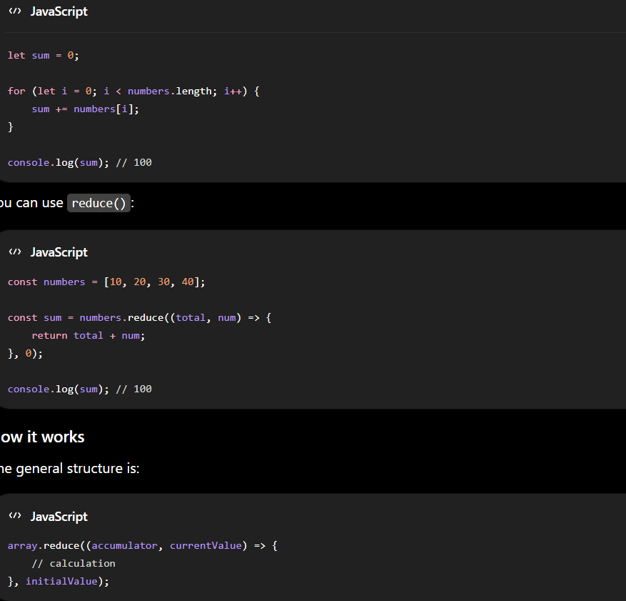
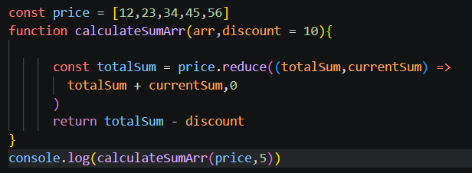
In the function, we have initialised discount as 10, this is known as default parameter.
It’s use is that in case we forget to give a discount as input, then 10 will be taken as a default value and perform the operation with 10 as the discount.
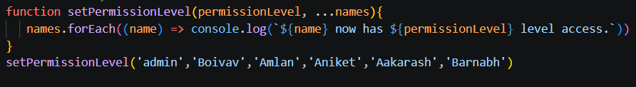
Here we have used …names as the rest parameter.
It is very important to make sure that the rest parameter is always placed at the last.
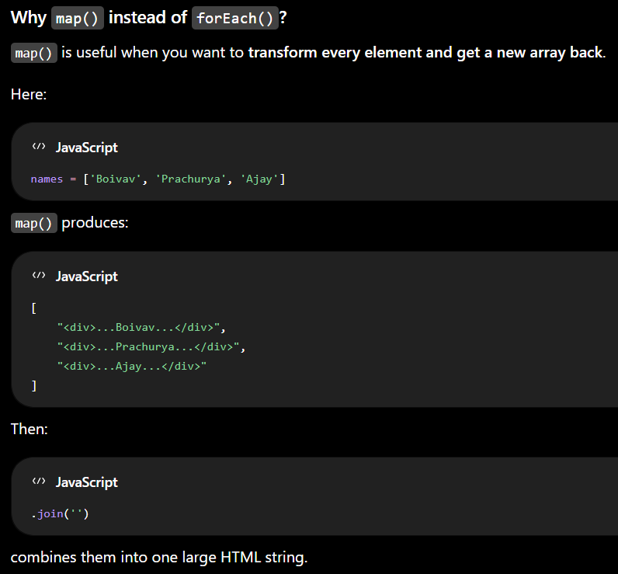
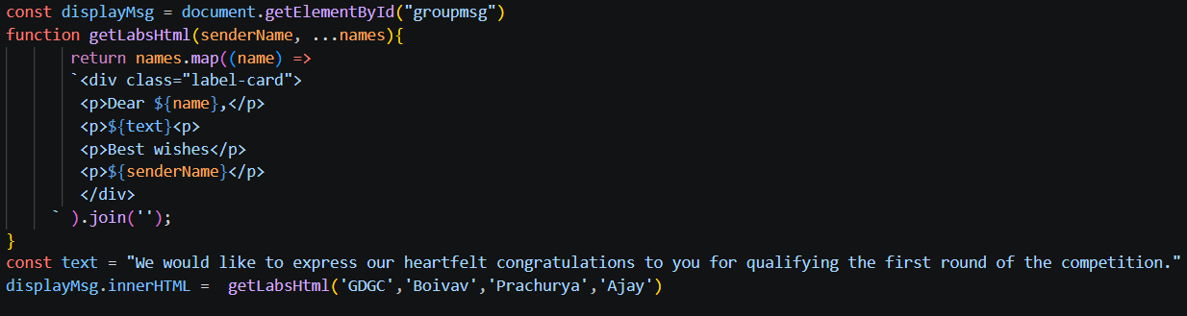
Asynchronous methods involve using functions such as setTimeout( ) and setInterval( )
The functions that we pass into other functions are known as Callback functions.
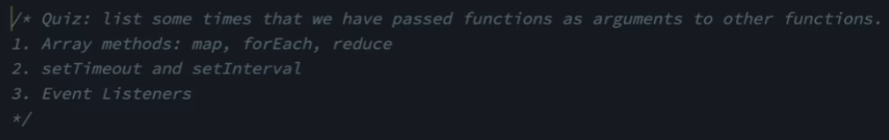
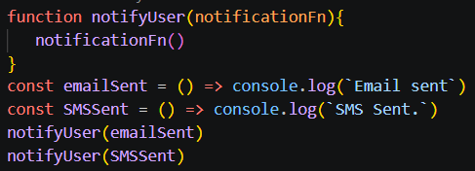
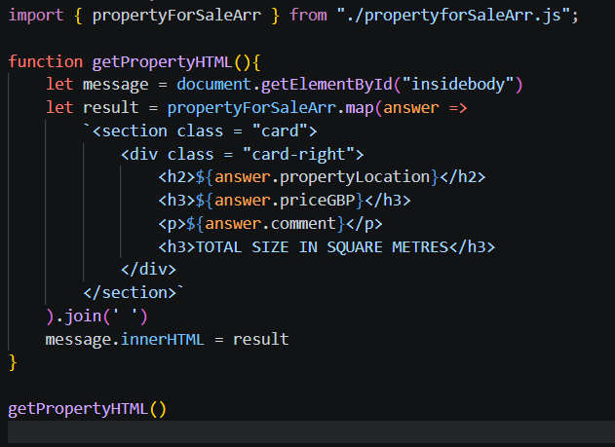
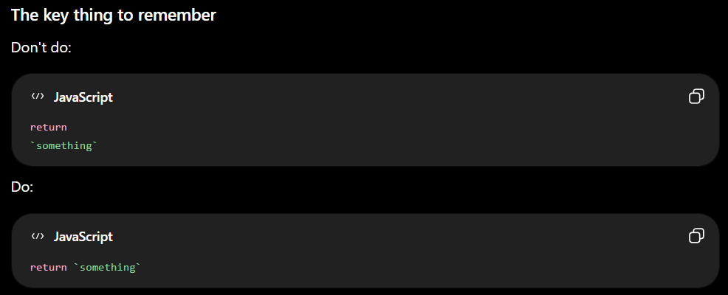
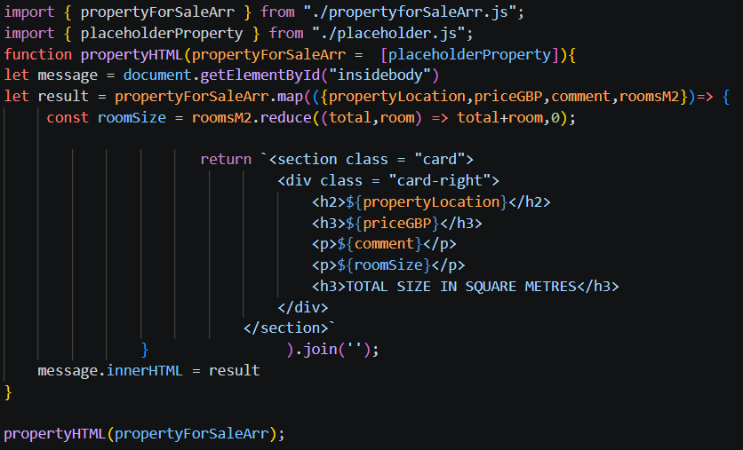
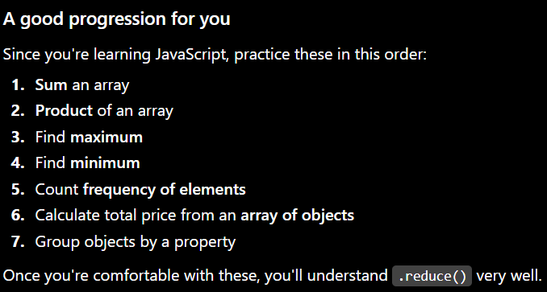

APIs – Application Program Interface
The user data such as the username, the password, and various other stuff are stored in the form of respective data structures in cloud. So while working, when we are working in application the APIs serve as the bridge to access that data, create various other stuff from it and read it, update it and delete it. APIs basically help us in connecting the frontend with the backend.
We use asynchronous javascript to access APIs.
